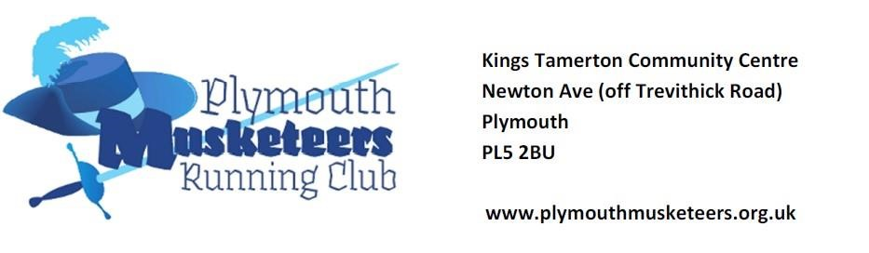
Plymouth Musketeers is a friendly and highly supportive running club for the complete beginner to the experienced runner. We are keen to meet with anyone who runs, whether for a social reason, a health and fitness reason or a competitive reason.
In addition, we would love to see non-runners who would like to know more about running or take up running and do not know how to start.
Enjoyable running for all levels is our aim and you will be helped and encouraged by UK athletics qualified coaches.
You can join as a club member and run with the club from the age of 16. We welcome anyone aged 15, but they need to be signed in as a non-member and must be accompanied by someone 16 or over.
Main club night: Thursdays 6:45pm to 8:30pm (Free refreshments provided)
There are also other runs organised in the week by coaches and members.
Club Tariffs
- First Club Night Session: Free
- Next 3 sessions: £1.00
- Subsequent sessions: Members £1.00 / Non-members £2.00
Membership runs from 1st April to 31st March.
To join as a member for:
- £26 - Individual Affiliated Membership (First Claim Club)
- £50 – Couple / Partner Affiliated Membership
- £10 – Second Claim Club or non-competitive runner (non-affiliated)
** Your membership fee includes a £16 English Athletics registration fee, which entitles you to a £2 discount on many race entries.
Members whose membership has lapsed are charged at £2 a session until they rejoin.

